***1.Validate assertion components for ui components:***

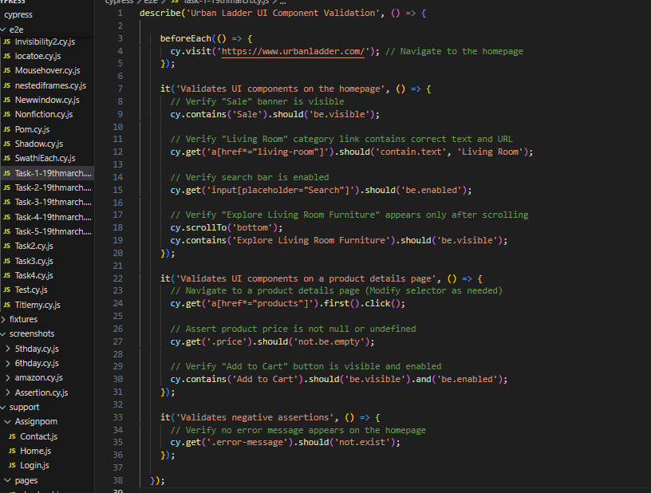

***2.Interact with hidden or visible elements:***

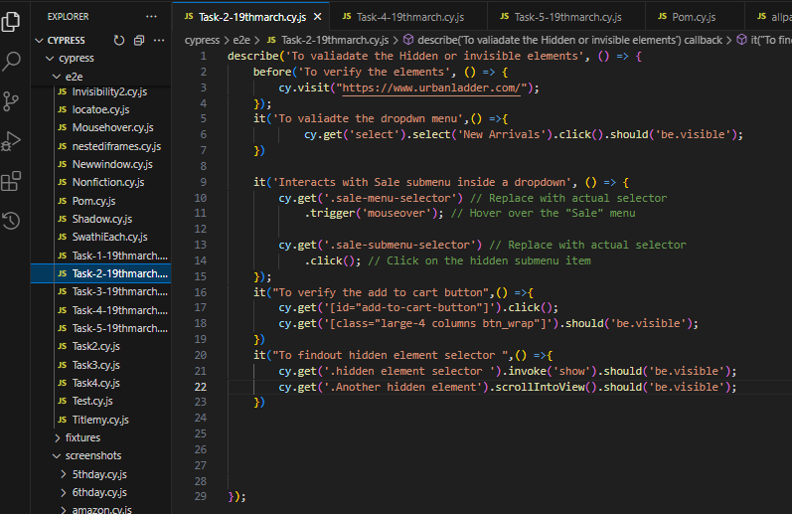

***3.Compare JQuery commands with cypress commands.***

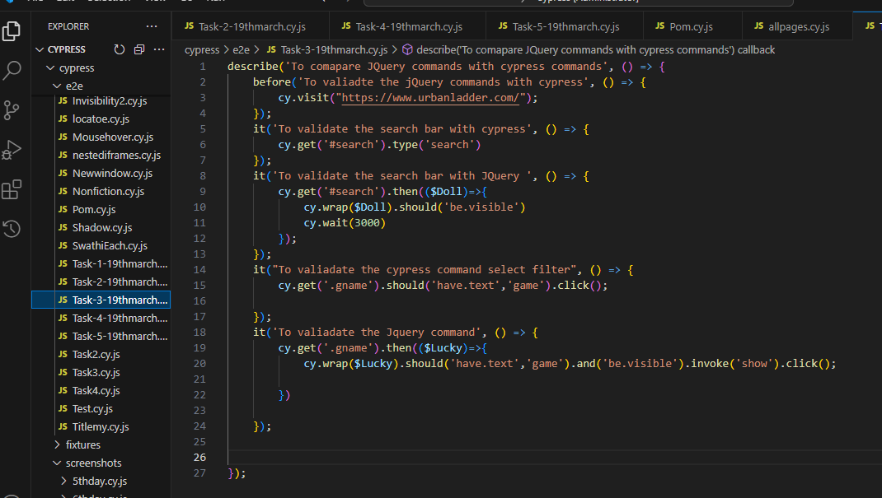

***4.Automate form element interactions:***

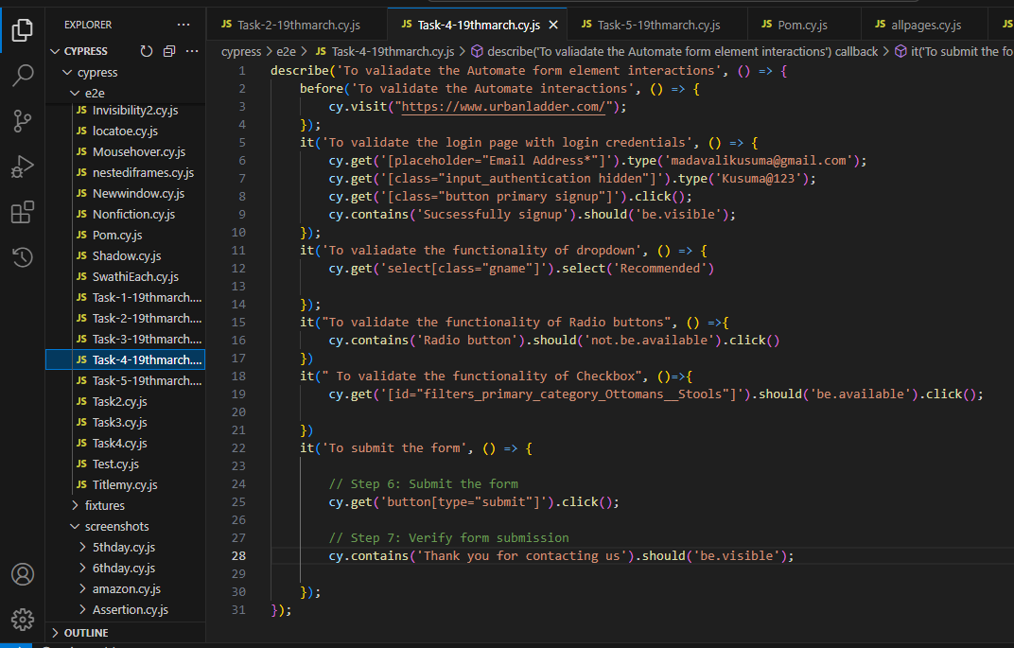

***5.Create real world test scenario:***

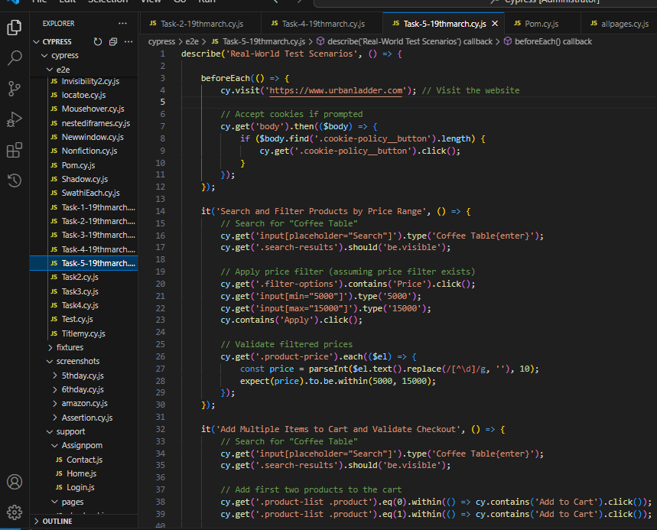

***Continuation:***

